SQL QUERIES

**A. KPI**

**1. Total Revenue:**

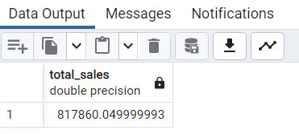SELECT SUM(total_price) AS Total_sales FROM pizza_sales

**2. Average Order Value**

SELECT SUM(total_price)/COUNT(DISTINCT order_id) AS Avg_order_value FROM pizza_sales

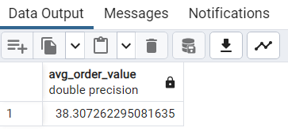

**3. Total Pizzas Sold**

SELECT SUM(quantity) AS total_pizza_sold FROM pizza_sales

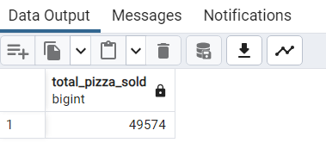

**4.Total Orders**

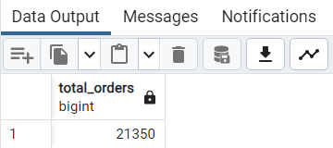SELECT COUNT(DISTINCT order_id) AS total_orders FROM pizza_sales

**5. Average Pizzas Per Order**

SELECT CAST(CAST(SUM(quantity) AS DECIMAL(10,2)) /

CAST(COUNT(DISTINCT order_id) AS DECIMAL(10,2)) AS DECIMAL(10,2))

AS Avg_Pizzas_per_order

FROM pizza_sales

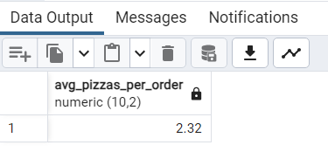

**B. Daily Trend for Total Orders**

SELECT to_char(order_date,'Day') AS Days,COUNT(DISTINCT order_id) AS Total_orders

FROM pizza_sales

GROUP BY 1

ORDER BY 2 DESC

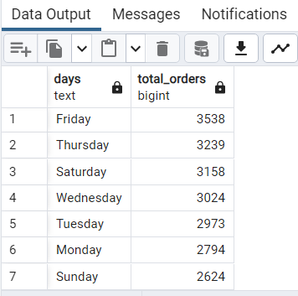

**C. Monthly Trend for Orders**

SELECT to_char(order_date,'Month') AS Months,COUNT(DISTINCT order_id) AS Total_orders

FROM pizza_sales

GROUP BY 1

ORDER BY 2 DESC

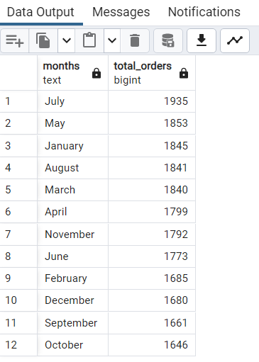

**D. % or total of Sales by Pizza Category**

SELECT pizza_category, CAST(SUM(total_price) AS DECIMAL(10,2)) AS total_revenue,

CONCAT(CAST(SUM(total_price) * 100 / (SELECT SUM(total_price) FROM pizza_sales) AS DECIMAL(10,2)),'%')

AS revenue_PCT

FROM pizza_sales

GROUP BY 1

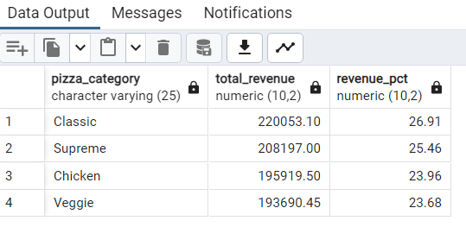ORDER BY 3 DESC

**E. % of Sales by Pizza Size**

SELECT pizza_size, CAST(SUM(total_price) AS DECIMAL(10,2)) AS total_revenue,

CONCAT(CAST(SUM(total_price) * 100 / (SELECT SUM(total_price) FROM pizza_sales) AS DECIMAL(10,2)),'%')

AS REVENUE_PCT

FROM pizza_sales

GROUP BY 1

ORDER by 3 DESC

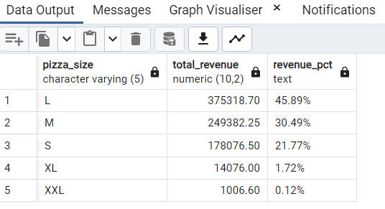

**F. Total Pizzas Sold by Pizza Category**

SELECT pizza_category,SUM(quantity) AS Total_Qty_Sold

FROM pizza_sales

GROUP BY 1

ORDER BY 2 DESC

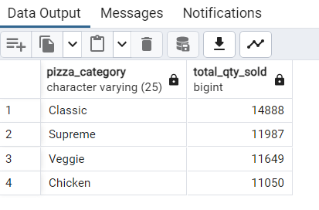

**G. Top 5 Pizzas by Revenue**

SELECT pizza_name, SUM(total_price) AS top_5_pizza_revenue

FROM pizza_sales

GROUP BY 1

ORDER by 2 DESC

LIMIT 5

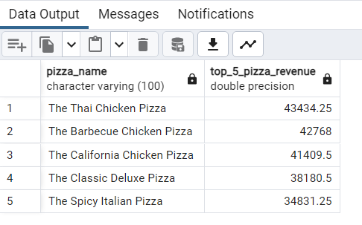

**H. Bottom 5 Pizzas by Revenue**

SELECT pizza_name, SUM(total_price) AS bottom_5_pizza_revenue

FROM pizza_sales

GROUP BY 1

ORDER BY 2

LIMIT 5

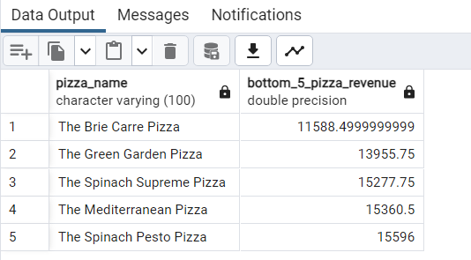

**I. Top 5 Pizzas by Quantity**

SELECT pizza_name, SUM(Quantity) AS top_5_pizza_sold

FROM pizza_sales

GROUP BY 1

ORDER BY 2 DESC

LIMIT 5

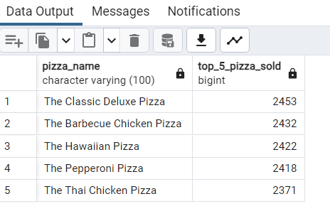

**J. Bottom 5 Pizzas by Quantity**

SELECT pizza_name, SUM(quantity) AS bottom_5_pizza_sold

FROM pizza_sales

GROUP BY 1

ORDER BY 2

LIMIT 5

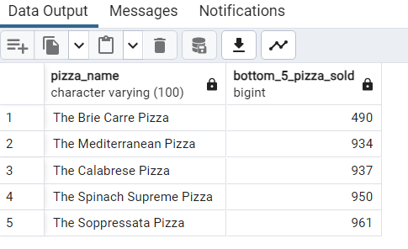

**K. Top 5 Pizzas by Total Orders**

SELECT pizza_name, count(distinct order_id) AS top_5_pizza_orders

FROM pizza_sales

GROUP BY 1

ORDER BY 2 desc

LIMIT 5

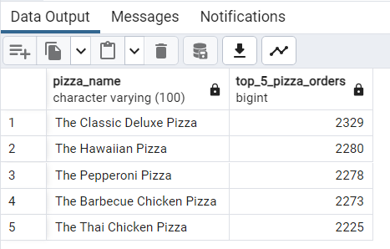

**L. Bottom 5 Pizzas by Total Orders**

SELECT pizza_name, count(distinct order_id) AS bottom_5_pizza_orders

FROM pizza_sales

GROUP BY 1

ORDER BY 2

LIMIT 5

